CCT College Dublin

Assessment Cover Page

Module Title: | Problem Solving for Industry
Assessment Title: | Capstone Pair Project
Lecturer Name: | Dr. Muhammad Iqbal
Student Full Name: | Caroline de Sa Teixeira, Heber Mota
Student Number: | 2020331, 2020317
Assessment Due Date: | 17/05/2024
Date of Submission: | 17/05/2024

Declaration

By submitting this assessment, I confirm that I have read the CCT policy on Academic Misconduct and understand the implications of submitting work that is not my own or does not appropriately reference material taken from a third party or other source. I declare it to be my own work and that all material from third parties has been appropriately referenced. I further confirm that this work has not previously been submitted for assessment by myself or someone else in CCT College Dublin or any other higher education institution.
Table of Contents

CCT College Dublin 0
Assessment Cover Page 0
Declaration 0
Introduction 2
Business Understanding 2
Assess Situation 2
Determine Data Mining & Machine Learning Goals 3
Data Understanding 4
MIT Licensing 5
Exploring Data 5
Data Preparation 12
Data Cleaning & Integration 12
Data Preparation & Construction 12
Modelling 15
Base Models: Random Forest & Decision Tree[7] 15
Final Estimator: Logistic Regression[8] 15
Ensemble Learning Techniques 16
Evaluation (AUMENTAR) 17
Deployment 18
Conclusion 19
Peer Reflection 20
Caroline 20
Heber 20
Referencing 22

Introduction

Business Understanding

The core objective of the Banking Solutions project is to make use of machine learning techniques to detect and prevent fraudulent transactions within a provided dataset effectively. Our approach involves constructing a robust system adept at managing financial data while also integrating additional features such as a currency converter to enhance financial management capabilities. Furthermore, we aim to utilize the properties of the dataset to generate insightful visualizations depicting customer behavior patterns. These visualizations will empower our clients to identify trends and valuable insights crucial for their business operations. Through these features, we will develop a comprehensive Banking Solutions initial product that in the future could stand out in the market, offering competitiveness.

Assess Situation
Before starting the implementation phase of our project, it's important to conduct a thorough assessment of the current situation. This assessment involves several key steps to ensure a clear understanding of the project's context, objectives, and constraints. In order to address these constraints, we are going to make use of CRISP-DM Framework[1] provided in class as the report guiding and documenting flow of this work. In other words, the following tasks will be achieved:

- Define Objectives: The first step is to clearly define the objectives of the project. This involves understanding the goals and desired outcomes. In the case of our Banking Solutions project, the primary objective is to detect and mitigate fraudulent transactions using machine learning techniques.
- Assess Data Availability and Quality: The success of our project relies heavily on the availability and quality of the data. We need to assess the accessibility of relevant datasets and evaluate their completeness, accuracy, and consistency. Additionally, we must consider any data privacy and security regulations that may impact our data collection and usage.
- Analyze Technical Requirements: Next, we need to analyse the technical requirements for implementing our solution. This includes assessing the hardware, software, and infrastructure needed to support our machine learning models, data visualization tools, and other components of the solution.
- Consider Time and Resource Constraints: Time and resource constraints play a crucial role in project planning and execution. We need to evaluate the project timeline and available resources to ensure feasibility and manage expectations effectively.
- Risk Assessment: Identifying and assessing potential risks is essential for proactive risk management. We need to analyse potential risks related to data quality, technical challenges, regulatory compliance, and project dependencies. Developing mitigation strategies for these risks will help minimize their impact on the project.
- Define Success Metrics: Finally, we need to define clear success metrics that will guide the evaluation of our project's outcomes. These metrics should align with the project objectives and provide measurable indicators of success.

Determine Data Mining & Machine Learning Goals
In determining data mining and machine learning goals, it is essential to align them with the objectives of the project. This involves identifying specific tasks and outcomes that leverage data mining and machine learning techniques to extract actionable insights and drive decision-making processes. These goals include Fraud Detection – utilizing machine learning algorithms to identify patterns and anomalies in financial transactions, enabling proactive detection and mitigation of fraudulent activities. By defining clear and measurable objectives, the project can focus on implementing effective solutions that deliver tangible benefits and add value to the organization.

Data Understanding

The Public Domain Database, curated by Petr Berka and Marta Sochorova, comprises financial data sourced from a Czech bank, encompassing details of over 5,300 bank clients and approximately 1,000,000 transactions. Furthermore, the dataset includes information on nearly 700 loans and close to 900 credit cards provided by the bank, all of which are represented within the data.
Regarding the data structure, each account in the dataset possesses both static attributes (e.g., creation date, branch address) delineated in the "account" relation, and dynamic attributes (e.g., transaction debits or credits, balances) provided in the "permanent order" and "transaction" relations. The "client" relation describes the attributes of individuals authorized to manage accounts, where one client may have multiple accounts, and multiple clients can manipulate a single account. The connections between clients and accounts are articulated in the "disposition" relation. Additionally, the "loan" and "credit card" relations outline services offered by the bank to its clients, with the possibility of multiple credit cards being issued to one account and a maximum of one loan being granted per account. Furthermore, the "demographic data" relation furnishes publicly available information about districts (e.g., unemployment rates), with potential insights into client demographics derived from this data. (Petr Berka and Marta Sochorova 2002) [2, 3].
Below, the Entity Relationship Diagram depicts the relationships of its features as shown:

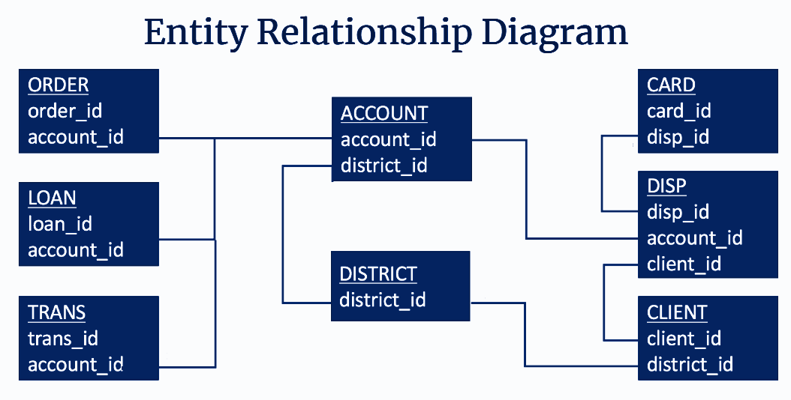
Diagram created by Heber Mota

MIT Licensing
Copyright 2024, Heber Mota, Caroline de Sá,
Permission is hereby granted, free of charge, to any person obtaining a copy of this dataset and associated documentation files (the "1999 Czech Financial Dataset - Real Anonymized Transactions Dataset"), to deal in the Dataset without restriction, including without limitation the rights to use, copy, modify, merge, publish, distribute, sublicense, and/or sell copies of the Dataset, and to permit persons to whom the Dataset is furnished to do so, subject to the following conditions:
The above copyright notice and this permission notice shall be included in all copies or substantial portions of the Dataset.
THE DATASET IS PROVIDED "AS IS", WITHOUT WARRANTY OF ANY KIND, EXPRESS OR IMPLIED, INCLUDING BUT NOT LIMITED TO THE WARRANTIES OF MERCHANTABILITY, FITNESS FOR A PARTICULAR PURPOSE AND NONINFRINGEMENT. IN NO EVENT SHALL THE AUTHORS OR COPYRIGHT HOLDERS BE LIABLE FOR ANY CLAIM, DAMAGES OR OTHER LIABILITY, WHETHER IN AN ACTION OF CONTRACT, TORT OR OTHERWISE, ARISING FROM, OUT OF OR IN CONNECTION WITH THE DATASET OR THE USE OR OTHER DEALINGS IN THE DATASET.
Source: 1999 Czech Financial Dataset - Real Anonymized Transactions - Public Domain Dataset | data.world

Exploring Data

After conducting an extensive Exploratory Data Analysis (EDA), we have gained valuable insights into the intricacies of our dataset. This comprehensive analysis has shown interesting features such as the ones presented below:
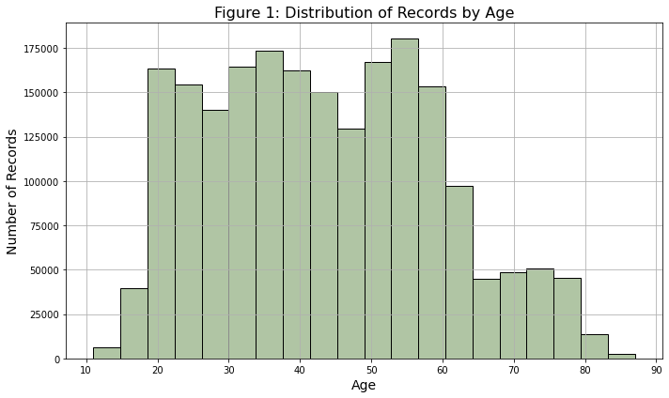
Figure 1: The graph portrays a notable concentration of individuals aged between 18 and 65, indicating a considerable level of activity within this demographic range. Furthermore, within this range, there is a distinct peak observed particularly within the age group between the 30s and 50s.
Figure 2: The majority of records cluster within the range of 325-370 euros on average, suggesting a prevalent income bracket among the sampled population. Interestingly, there is a secondary peak observed around 500 euros, indicating another significant concentration of wealth. It's worth noting that these figures have been converted from Czech Koruna to Euro, providing a comprehensive perspective on the financial landscape within the dataset. This observation underscores the existence of distinct salary groups within the population, potentially reflecting varying socio-economic factors or industry trends.

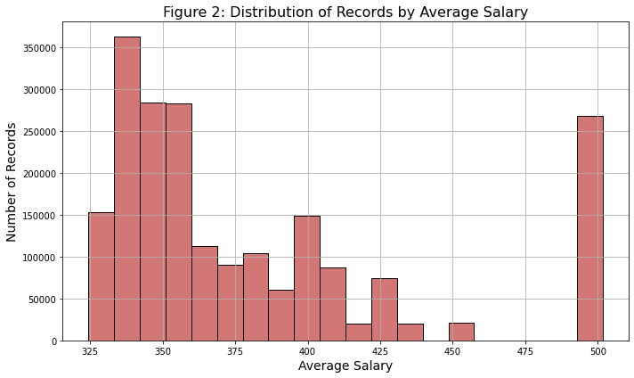

Figure 3: The graph illustrates a clear trend in transactional preferences, with debit cards emerging as the most commonly utilized payment method, followed by credit transactions and cash withdrawals. This observation underscores the significance of digital payment methods in modern financial transactions, reflecting a widespread reliance on debit cards for everyday purchases and transactions. Additionally, the prominence of credit transactions highlights the continued relevance of credit-based purchasing in consumer spending habits.
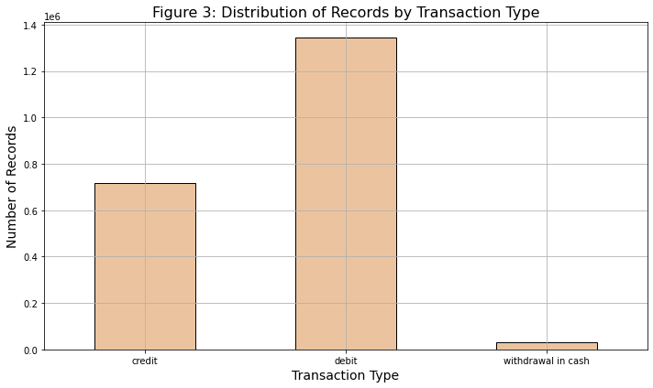

Figure 4: The distribution of gender within the records demonstrates a balanced representation between male and female individuals. The even distribution suggests a fair and equitable representation of both genders, which is essential for ensuring unbiased analyses and decision-making processes. This gender balance within the dataset provides a solid foundation for conducting comprehensive and inclusive analyses, ultimately contributing to more robust insights and outcomes.
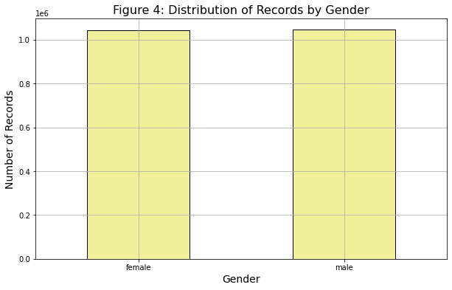

Figures 5 & 6: Both graphical analysis reveals notable patterns in transaction activity across different districts and standpoints. Figure 5 focuses on the total transaction and order amounts whereas Figure 6 focuses on the average salaries which shows that they are directly connected. The capital city, Prague, with the highest average salary is demonstrating a significantly high transaction volume reaching 100 million units. Following behind is Ostrava, Mesto, with transaction activity hovering over the 20 million mark, indicating a substantial level of economic activity in the region.
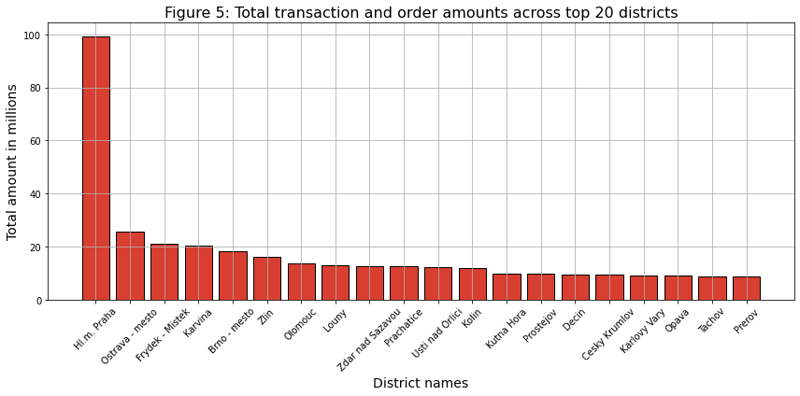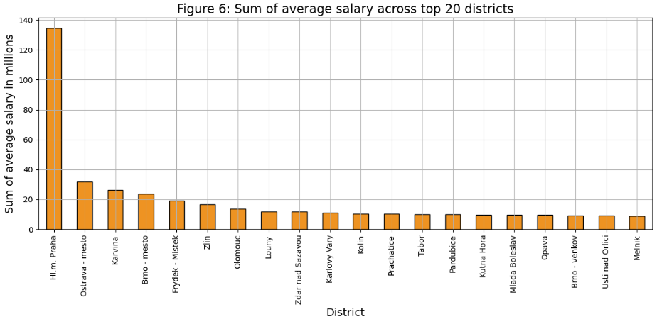

Figure 7: Upon examining the graph depicting the total order amount across the top 20 receivers, a striking observation emerges. It becomes evident that a particular receiver stands out significantly, commanding over 800k orders, which contrasts with the second and third place receivers, each with approximately 600k orders. The remaining receivers in the top 20 exhibit a gradual decline in order volumes, ranging from 500k to 300k orders. This discrepancy emphasizes the dominance of the top-ranking receiver and highlights the considerable gap between their order volumes.
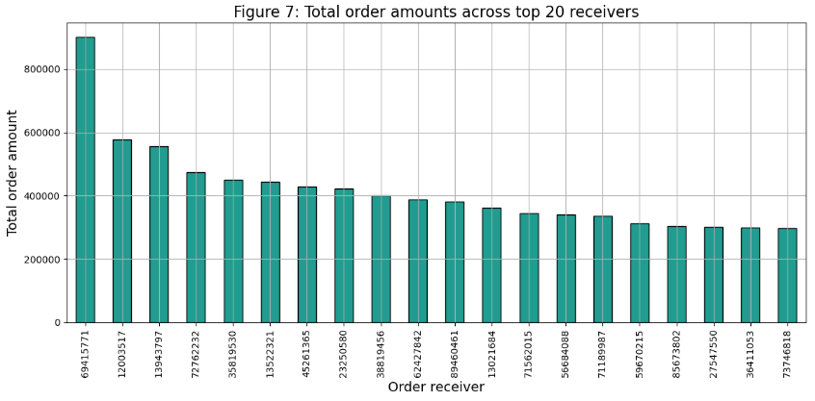

Figure 8: Household payments constitute the predominant share, comprising 77.3% of the total order amounts. Following behind, loan payments account for 15.2% of the total, indicating a significant but comparatively lesser portion. Meanwhile, leasing payments and insurance payments represent around 4% of the total order amounts each. This distribution highlights the substantial contribution of household payments to the overall transaction volume, underscoring their importance within the analyzed dataset.
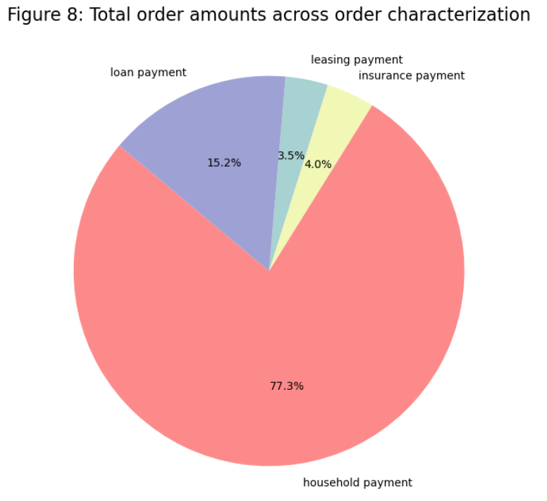

Figure 9: While the previous visualization emphasized household payments in terms of appearances, a notable contrast emerges with the category of interest credited in values. In this instance, the transaction amounts significantly surpass those of other categories. This observation underscores a distinctive pattern where interest credited transactions exhibit substantially higher values compared to other types of transactions depicted in the graph.
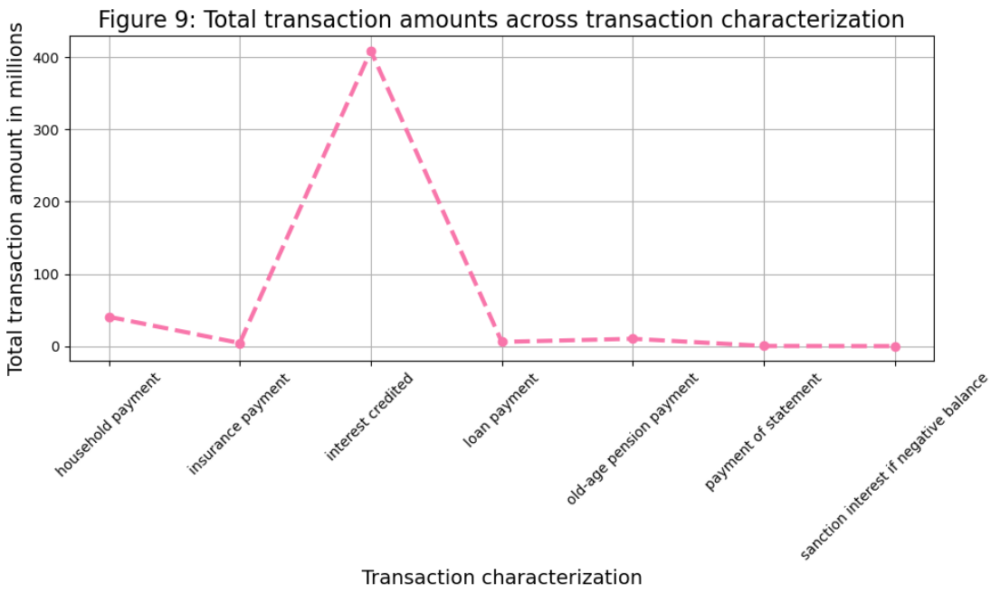

Figure 10: The data illustrates that credit card transactions predominantly stand within the lower spending range, typically not exceeding 750 transactions. In contrast, transactions made with debit cards extend beyond this threshold, reaching up to 2.000 transactions. Additionally, a small proportion of transactions involve cash withdrawals exceeding 2.000. This observation underscores the differing spending behaviors associated with each transaction type, with credit card transactions skewed towards lower values, while debit card transactions encompass a broader range of expenditure.
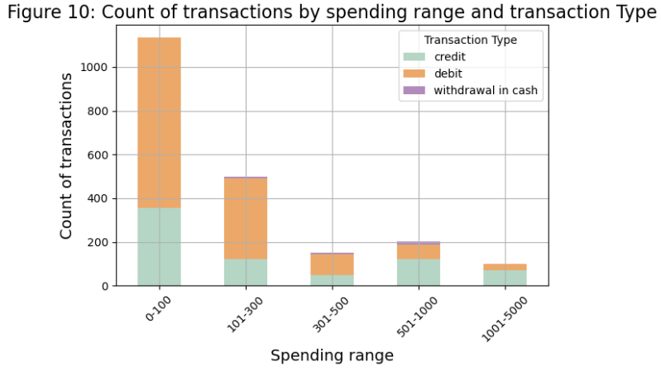
Now, we are going to explore the Categorical variables:
Figure 11: This figure shows that cash withdrawals emerge as the most prevalent transaction characteristic, comprising nearly 800,000 records. Following closely behind is remittance to another bank, with approximately 600,000 instances, while interest credited transactions surpass 300,000. Moreover, credit in cash transactions and collections from another bank are each recorded nearly 300,000 and 100,000 times, respectively.
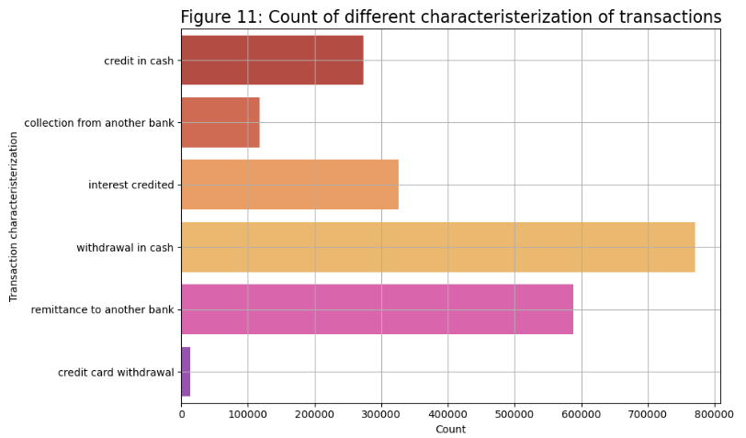

Figure 12: In this graph we can notice that interest credited emerges as the most prevalent transaction type, boasting the highest count. Following this, old-age pension payment, household payment, payment of statement, insurance payment, and loan payment are also observed at a considerable distance from interest credited.
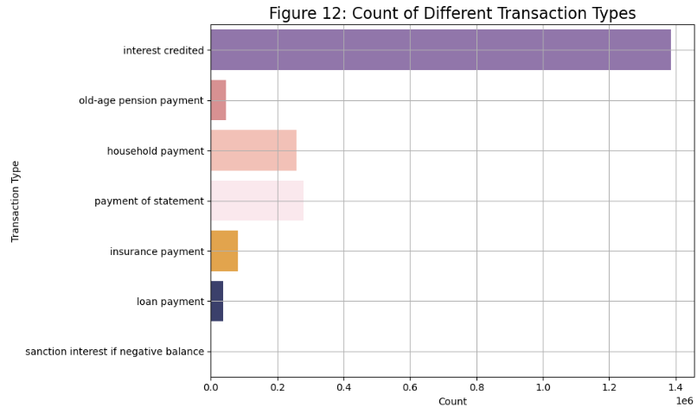

Data Preparation

Data Cleaning & Integration
In our project workflow, we made a choice to exclude the card and loan datasets from our analysis. These datasets were irrelevant as they did not provide any pertinent information necessary for the application of our machine learning model. However, the disp dataset played a crucial role in facilitating the integration of the account and client datasets. Yet, after this integration was achieved, all columns from the disp dataset were promptly discarded, as they no longer served a purpose in our analysis, dropping from 43 columns altogether to 15.
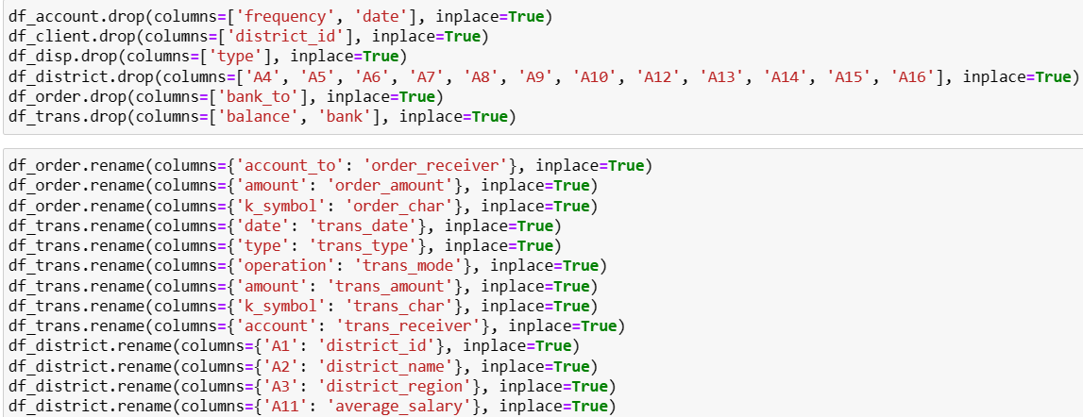
Screenshot 1: columns being dropped and renamed
Before merging the datasets, we took a series of preparatory steps to ensure data integrity and coherence. Firstly, we designated the account_id column as the index, facilitating seamless merging operations. To enhance clarity and comprehension, most columns underwent a renaming process to provide better insight into the data.[4]

Data Preparation & Construction
We also added to the dataset additional information from the client's date of birth, specifically creating two new columns: gender and age. Additionally, to standardize the data and facilitate interpretation, transaction operation and characterization values were translated from Czech to English. Moreover, currency-related columns underwent conversion from Czech Koruna to Euros to maintain uniformity and better understanding (Screenshot below). To address missing data, null values were imputed using information sourced from other datasets, employing statistical measures such as mean and mode values.
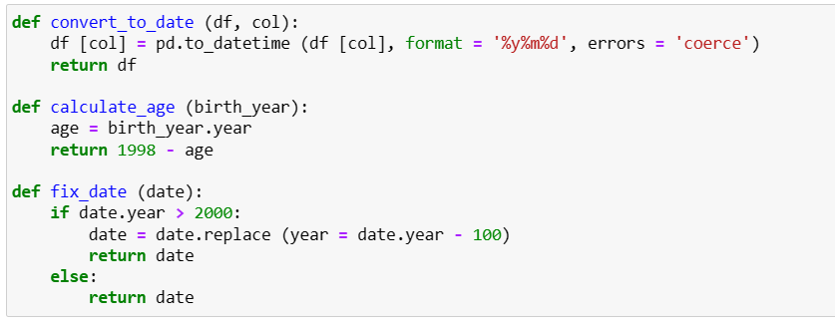
Screenshot 2: date formatation, birthday calculation

Upon completion of these preparatory measures, the six remaining datasets were consolidated through merging operations, primarily utilizing the account_id column as the key identifier. Subsequently, further redundant columns were eliminated from the merged dataset, and a systematic order was established for the retained columns.
By meticulously executing these preparatory steps, we ensured that our datasets were appropriately curated and structured, laying a solid foundation for subsequent analysis and model application.

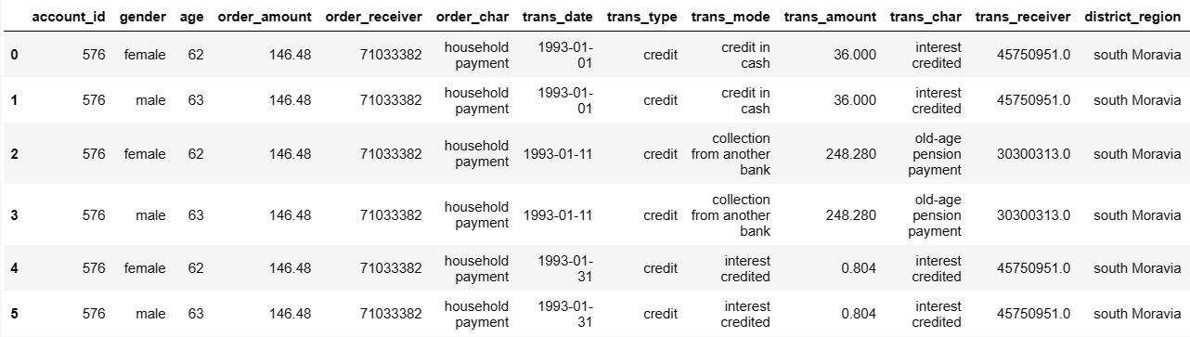
Screenshot 3: dataset post cleaning, renaming, currency conversion

I've employed the StandardScaler[5] to normalize all numerical attributes, ensuring they share a common scale with a mean of 0 and a standard deviation of 1. This process involves subtracting the mean value from each attribute and dividing it by the standard deviation. StandardScaler alters the data to follow a Gaussian distribution with a mean of 0 and a standard deviation of 1. This practice aids in avoiding bias during dataset training and enhances algorithm optimization.
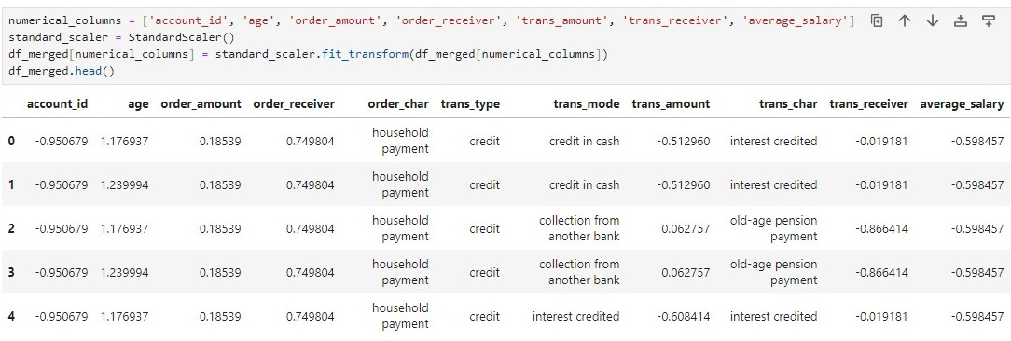Screenshot 4: StandardScaler being applied to merged dataframe

One-Hot Encoding[6] is a method to transform categorical columns into binary sub-columns containing numeric data. This process involves encoding each unique category within a categorical column into its own binary sub-column. For instance, if a transaction's type is identified as "credit," the corresponding binary sub-column, such as "trans_type_credit," will be assigned a value of 1 (true). Similarly, if the transaction type falls under a different category, the "trans_type_credit" column will hold a value of 0 (false). This encoding technique is applied consistently across all categorical features, ensuring that only one of the binary sub-columns per feature contains a value of 1, while the rest hold values of 0.

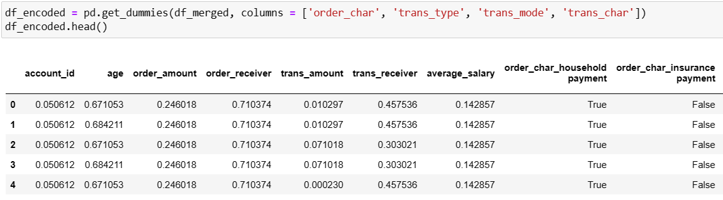Screenshot 5: Data converted using One-Hot Encoding

Modelling

The selection of base models and the final estimator for stacking relies on a variety of factors, including the characteristics of the dataset, the complexity of the problem at hand, and the individual performance of each model. Let's assess the appropriateness of the chosen models for fraud detection:

Base Models: Random Forest & Decision Tree[7]
Random Forest (RF) and Decision Tree (DT) are frequently utilized classifiers within ensemble methodologies like stacking. RF is recognized for its resilience against overfitting and its capability to capture intricate relationships within the data. DT, on the other hand, is straightforward and easily interpretable, rendering it suitable for capturing straightforward decision rules. Both models possess the capacity to capture different facets of the data, potentially complementing each other within a stacked ensemble framework.

Final Estimator: Logistic Regression[8]
Logistic Regression (LR) serves as a linear classifier commonly employed as the final estimator in stacking due to its simplicity and interpretability. LR is well-suited for binary classification tasks such as fraud detection and can furnish insights into the significance of various features. By setting parameters such as max_iter to a high value like 1000, LR ensures ample iterations to converge and determine optimal coefficients. In summary, the chosen base models (RF and DT) and final estimator (LR) appear well-suited for fraud detection:
- RF and DT possess complementary strengths, adept at capturing both complex and simple data patterns.
- LR provides interpretability and can quickly combine the predictions from the base models within the stacked ensemble.

Ensemble Learning Techniques

Bagging, Stacking and Boosting[9] are ensemble learning techniques used to improve machine learning model performance. Bagging involves training multiple models independently on different subsets of the data and then combining their predictions, typically through averaging or voting. Random Forest is a popular example of bagging. [10]
In contrast, stacking trains multiple models sequentially on the entire dataset and then uses a meta-model to combine their predictions. Stacking encourages model diversity and can utilize various algorithms as base models and meta-models. Both bagging and stacking aim to enhance model generalization and robustness by leveraging multiple models to capture different aspects of the data and reduce overfitting.
AdaBoost, short for Adaptive Boosting, is a machine learning technique that combines multiple weak learners to create a strong classifier. It operates iteratively, adjusting the weights of misclassified data points to prioritize them in subsequent training rounds. Each weak learner focuses on the instances that were difficult to classify by previous learners, gradually improving the overall accuracy. By aggregating the predictions of these weak learners, AdaBoost constructs a robust model capable of handling complex classification tasks. Its adaptability and ability to handle noisy data make it a popular choice in various domains.
Because AdaBoost showed better results – presenting a 89,31% accuracy – we decided to exclusively utilize it to create the fraud column in our analysis. By taking advantage of the diversity of multiple models and their ability to capture different nuances of the data, AdaBoost enabled us to achieve superior results compared to other ensemble techniques. Therefore, we opted to employ stacking specifically for the task of identifying fraudulent activities, ensuring our model's accuracy and reliability in this critical aspect of our analysis.

Evaluation

In the evaluation section of our report, we present the performance of various algorithms used in our analysis. At first, we tried applying models to the data without using the SMOTE technique (Synthetic Minority Oversampling Technique) which led to extremely undesidered figures in terms of accuracy, so then we tried using SMOTE and finally the results were increasingly better. In addressing this class imbalance, randomly selecting minority class samples from the dataset and duplicating them, this method enhances the representation of the minority class. This augmentation process serves to address the imbalance issue, ensuring that the model receives sufficient exposure to the minority class instances, which increases its ability to make accurate predictions in all classes.
After applying SMOTE to the ensemble learning techniques, the stacking classifier achieved an accuracy of 0.8915, demonstrating its effectiveness in identifying fraudulent activities. Similarly, the bagging classifier showed strong performance with an accuracy of 0.8930, while the AdaBoost classifier held an accuracy of 0.8931. These results highlight the reliability of ensemble learning techniques used in our fraud detection algorithm, mixing multiple models to enhance predictive accuracy as shown below:

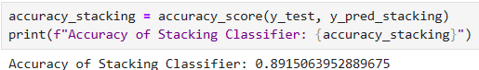
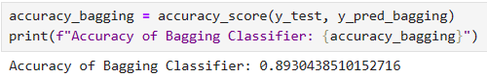
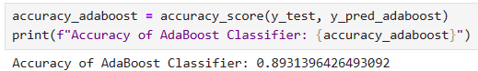

Screenshot 6, 7 and 8: Accuracy of Stacking (89,15%), Bagging (89,30%), AdaBoost (89,31%) Classifiers

Similarly to the screenshots shown above, we can also note their high performance from this graph:

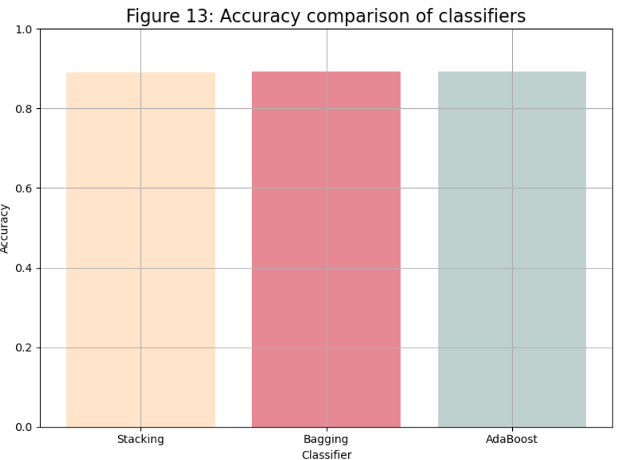

Deployment

Deployment: plan deployment; plan monitoring and maintenance; produce final report; review project

Conclusion

The fraud detection project has been a challenging journey marked by numerous obstacles and opportunities for personal and professional growth. From data cleaning and preparation to navigating the wide and deep availability of models to select from and evaluate, each phase of the project presented its own unique challenges that required dedication and resilience from us.
One of the most difficult challenges we encountered was the huge scale and complexity of the dataset. With 8 distinct datasets to merge and pre-process, the data cleaning and preparation process demanded continued effort, with adjustments and refinements being made until the completion of the project. Similarly, the process of model selection posed its own set of challenges. As we thought we had found out the perfect algorithm, we then faced their limitations in accurately detecting fraudulent activities. This led to a deeper exploration of alternative methodologies and the refinement of our strategies to better align with our objectives.
Furthermore, the culmination of our efforts is evidenced by the remarkable results achieved through the implementation of various ensemble learning techniques. The base models such as Random Forest and Decision Tree, in conjunction with a final estimator like Logistic Regression, enabled us to achieve an impressive accuracy rate of 89,31%. The utilization of ensemble methods, including bagging, stacking, and boosting, played an important role in enhancing the predictive capabilities of our models. These techniques not only facilitated the fusion of diverse predictive models but also mitigated the shortcomings of individual algorithms, resulting in a robust and highly accurate fraud detection system.

Peer Reflection

Caroline
I have learned a lot about data cleaning and data preparation during the two months of working on this project. It took extensive research, constant trial and error and many hours of debugging to achieve the final results present in this project. My main tasks involved cleaning and preparing the dataset, as well as applying the machine learning models to the training and testing data. The work wasn’t linear, as I always had to swap between those three tasks in order to achieve the current outcome. Many decisions that we made at the beginning of the project were altered along the way, and dozens of models were applied to the data until we finally found what works.
Undoubtedly, the dataset itself showed to be one of the most difficult challenges. The vast financial data split across 8 distinct datasets needed to go through a merging process to consolidate them into a cohesive, single dataset. The exhaustive cleaning, preparation, and encoding stages accounted for the majority (about 90%) of the project's workload, persistently requiring adjustments and refinements up until completion.
That said, the most rewarding part was making it work. I can say for myself and for Heber that we learned a lot during the process, both through research and from errors. It was very energy and time-consuming, but seeing it work in the end is very satisfying.

Heber
Working on this fraud detection project has provided me with a valuable opportunity to deeper understand the intricacies of machine learning and its methodologies as it brought a series of challenges, moments of being stuck and requiring extensive research, making us rethink our approaches. Another significant challenge emerged during the model selection phase. Despite initial enthusiasm for a particular algorithm, we soon realized its limitations in accuracy to detect fraudulent activities. This experience enriched my understanding of the field and enhanced my skill set, particularly in collaboration. Throughout the project, my focus was:
I assumed the responsibility of meticulously documenting various aspects of our work that served as our deliverables apart from the code itself, including writing this report, designing the academic poster, and creating the PowerPoint presentation. While I carried out these tasks, Caroline offered her insights through revisions, ensuring the clarity and coherence of our documentation but focusing on the data preparation and modelling.
I also conducted extensive exploratory data analysis (EDA), which laid the foundation for our subsequent modeling efforts. By meticulously examining the dataset, identifying patterns, and understanding its structure, I contributed to the formulation of effective strategies for fraud detection.
This project not only increased my technical skills but also reinforced the importance of effective communication and collaboration in achieving our goals. The challenges faced served as valuable learning experiences, highlighting the complexities in programming and the importance of constant research, adaptability, and collaborative problem-solving.

Referencing

- CRISP-DM Framework. (2024). Moodle. [Online]. Available at: https://moodle.cct.ie/mod/folder/view.php?id=33135 (Accessed: 13 May 2024).

- 1999 Czech Financial Dataset - Real Anonymized Transactions - dataset by lpetrocelli (2019) data.world. Available at: https://data.world/lpetrocelli/czech-financial-dataset-real-anonymized-transactions (Accessed: 12 March 2024).

- PKDD’99 Discovery Challenge (no date) Financial Data description: Available at: https://sorry.vse.cz/~berka/challenge/pkdd1999/berka.htm (Accessed: 19 March 2024).

- Real Python (2023) Pythonic Data Cleaning With pandas and NumPy, Real Python. Real Python. Available at: https://realpython.com/python-data-cleaning-numpy-pandas/ (Accessed: 19 March 2024).

- Geek Python. (2023). How to Use sklearn StandardScaler. Available at: https://geekpython.in/how-to-use-sklearn-standardscaler (Accessed: 14 May 2024)

- Brownlee, J. (2020) Why One-Hot Encode Data in Machine Learning?, MachineLearningMastery.com. Available at: https://machinelearningmastery.com/why-one-hot-encode-data-in-machine-learning/ (Accessed: 22 March 2024).

- Analytics Vidhya. (2020). Decision Tree vs Random Forest Algorithm. Analytics Vidhya. Retrieved May 14, 2024, from https://www.analyticsvidhya.com/blog/2020/05/decision-tree-vs-random-forest-algorithm/#:~:text=A%20decision%20tree%20is%20more,%2C%20healthcare%2C%20and%20deep%20learning.

- Murali, V. (2023). Ensemble Learning: Combining Models for Better Predictions. Medium. Retrieved May 14, 2024, from https://vivek-murali.medium.com/ensemble-learning-combining-models-for-better-predictions-53a4c80cb18a

- Medium. (2023). Ensemble Models: How to Make Better Predictions by Combining Multiple Models with Python Codes. Medium. Retrieved May 14, 2024, from https://aryanbajaj13.medium.com/ensemble-models-how-to-make-better-predictions-by-combining-multiple-models-with-python-codes-6ac54403414e

- Maheshhkanagavell. (2023). Exploring Decision Trees, Random Forest, Logistic Regression, KNN, Linear Regression, SVM, RNN, LSTM, and LightGBM for Effective Data Analysis. Medium. Available at: https://medium.com/@maheshhkanagavell/exploring-decision-trees-random-forest-logistic-regression-knn-linear-regression-svm-rnn-bf52fa94a066 (Accessed: 15 May 2024).

- Tavasoli, S. (2024) Essential Machine Learning Algorithms: Top 10 to Master in 2024: Simplilearn, Simplilearn.com. Simplilearn. Available at: https://www.simplilearn.com/10-algorithms-machine-learning-engineers-need-to-know-article (Accessed: 10 March 2024).

- OpenAI. (n.d.). ChatGPT. Retrieved May 14, 2024, from https://openai.com/chatgpt (uses include: brainstorming and refining ideas; fine tuning research; drafting an outline to organise thoughts and checking grammar and code errors).

- Python - Replace Missing Values with Mean, Median & Mode, Analytics Yogi. Available at: https://vitalflux.com/pandas-impute-missing-values-mean-median-mode/ (Accessed: 19 March 2024).

- Kosourova, E. (2023) Types of Data Plots and How to Create Them in Python, DataCamp. DataCamp. Available at: https://www.datacamp.com/tutorial/types-of-data-plots-and-how-to-create-them-in-python (Accessed: 19 March 2024).

- Brownlee, J. (2023) Your First Machine Learning Project in Python Step-By-Step, MachineLearningMastery.com. Available at: https://machinelearningmastery.com/machine-learning-in-python-step-by-step/ (Accessed: 19 March 2024).

- Argaadya. (n.d.). CRISPR/Cas9 Genome Editing: Principle, Applications, and Challenges. RPubs. Retrieved May 14, 2024, from https://rpubs.com/Argaadya/crispr_dm

- Real Python (2023) Pythonic Data Cleaning With pandas and NumPy, Real Python. Real Python. Available at: https://realpython.com/python-data-cleaning-numpy-pandas/ (Accessed: 19 March 2024).

- MadhuBabu (2021) How to Handle Date and Time Columns in Python: Feature Engineering: Machine Learning, Medium. Analytics Vidhya. Available at: https://medium.com/analytics-vidhya/how-to-handle-date-and-time-columns-in-python-feature-engineering-machine-learning-254e45a031ae (Accessed: 22 March 2024).

- Ali, M. (2023) Handling Machine Learning Categorical Data with Python Tutorial, DataCamp. DataCamp. Available at: https://www.datacamp.com/tutorial/categorical-data (Accessed: 22 March 2024).

- Hyperparameter Tuning Using Grid Search and Random Search in Python (no date) KDnuggets. Available at: https://www.kdnuggets.com/2022/10/hyperparameter-tuning-grid-search-random-search-python.html (Accessed: 10 May 2024).

- Sahagian, G. (2020) What is Random State 42?, Medium. Medium. Available at: https://grsahagian.medium.com/what-is-random-state-42-d803402ee76b (Accessed: 10 May 2024).
- Top difference between training data and testing data (2023) Testsigma Blog. Available at: https://testsigma.com/blog/difference-between-training-data-and-testing-data/ (Accessed: 11 May 2024).

- Bajaj, A. (2023) Ensemble Models: How to Make Better Predictions by Combining Multiple Models with Python Codes..., Medium. Medium. Available at: https://aryanbajaj13.medium.com/ensemble-models-how-to-make-better-predictions-by-combining-multiple-models-with-python-codes-6ac54403414e (Accessed: 14 May 2024).

- RandomOverSampler# (no date) RandomOverSampler - Version 0.12.2. Available at: https://imbalanced-learn.org/stable/references/generated/imblearn.over_sampling.RandomOverSampler.html (Accessed: 14 May 2024).

- Brownlee, J. (2021) Random Oversampling and Undersampling for Imbalanced Classification, MachineLearningMastery.com. Available at: https://machinelearningmastery.com/random-oversampling-and-undersampling-for-imbalanced-classification/ (Accessed: 14 May 2024).

- GeeksforGeeks (2022) Online Payment Fraud Detection using Machine Learning in Python, GeeksforGeeks. GeeksforGeeks. Available at: https://www.geeksforgeeks.org/online-payment-fraud-detection-using-machine-learning-in-python/ (Accessed: 14 May 2024).

- Ensemble methods in Python: stacking (no date) Educative. Available at: https://www.educative.io/answers/ensemble-methods-in-python-stacking (Accessed: 15 May 2024).

- AI, T. (2022) Ensemble Learning - AdaBoost with Python, Medium. Medium. Available at: https://tirendazacademy.medium.com/ensemble-learning-adaboost-with-python-8332778fbb61#:~:text=A%20guide%20on%20how%20to,)%20algorithm%20with%20scikit%2Dlearn.&text=AdaBoost%20is%20a%20boosting%20method,starting%20point%20for%20understanding%20boosting. (Accessed: 15 May 2024).

- AI, T. (2022) Ensemble Learning - AdaBoost with Python, Medium. Medium. Available at: https://tirendazacademy.medium.com/ensemble-learning-adaboost-with-python-8332778fbb61#:~:text=A%20guide%20on%20how%20to,)%20algorithm%20with%20scikit%2Dlearn.&text=AdaBoost%20is%20a%20boosting%20method,starting%20point%20for%20understanding%20boosting. (Accessed: 15 May 2024).

